**Some Introduction Of JQuery :**

* **JQuery is a Library of Java-Script. JQuery Means “WRITE-LESS & DO MORE.”**
* **It Supports AJAX Technology**
* **It has Large And Advanced Set of Functionalities.**

**Syntax :**

* **$(selector).action()**
* **$ sign denotes the access to JQuery. The (selector) finds the HTML elements such as <p>,<div>,<h1>,<button> etc .**
* **The action() denotes the actions to be performed on selector elements.**
* **$(document).ready(event) : All the JQuery methods are written in document ready event .**
* **In Every JQuery File , you Should Add the CDN File. I provide that CDN File below:**

**CDN File :** [**https://code.jquery.com/jquery-3.6.0.js**](https://code.jquery.com/jquery-3.6.0.js)

**Note : Practical won’t Run if you don’t add CDN File.**

**Fade() Methods :**

1. **FadeIn() :**

**<!DOCTYPE html>**

**<html>**

**<head>**

**<title>Fade in</title>**

**<script src="https://code.jquery.com/jquery-3.6.0.js">**

**</script>**

**<script>**

**$(document).ready(function()**

**{**

**$("button").click(function()**

**{**

**$("#div1").fadeIn();**

**$("#div2").fadeIn("slow");**

**$("#div3").fadeIn(2000);**

**}**

**); }**

**);**

**</script>**

**</head>**

**<body>**

**<p>Demonstrate on Fadein() function</p>**

**<button> click</button>**

**<div id="div1" style="background-color: blue;width: 80px;height:80px;display:none;"></div><br>**

**<div id="div2" style="background-color: red;width: 80px;height:80px;display:none;"></div><br>**

**<div id="div3" style="background-color: greenyellow;width: 80px;height:80px;display:none;"></div><br>**

**</body>**

**</html>**

* **In Above Practical, line 6 , we add the CDN file. <script src=”**[**https://code.jquery.com/jquery-3.6.0.js**](https://code.jquery.com/jquery-3.6.0.js)**”>**
* **it is Necessary to add cdn in each Jquery’s Work.**
* **Here, $(document).ready(function()) is our Main Function. In this function we add the button .**
* **We provide #div id for each Box. In every fadein() method , I have written “slow”, 2000. It means , it takes some time to display in browser.**
* **You also write “fast” in fadein method as per your convinion.**
* **OUTPUT : FIG 1**

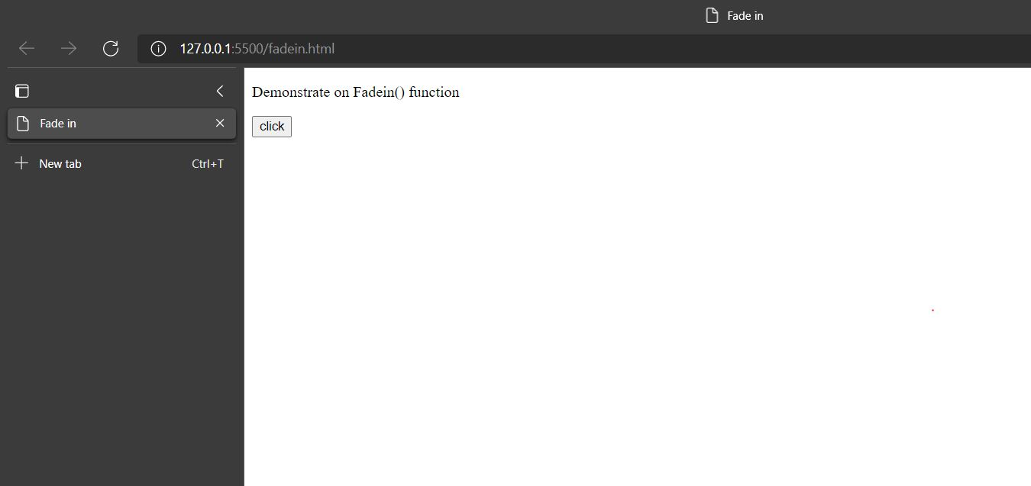

**FIG2**

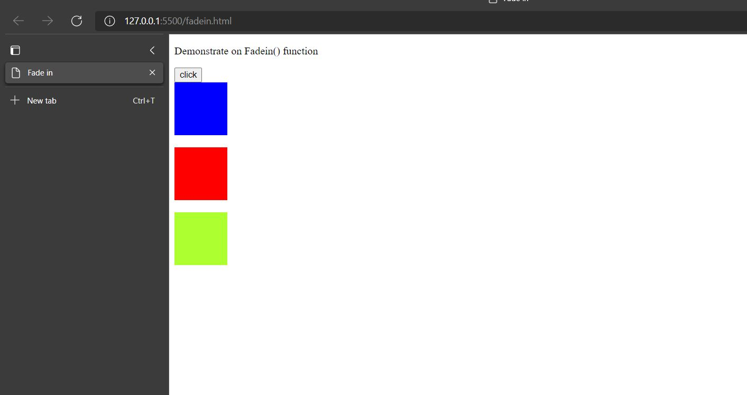

* **After the clicking on Click button, Output will be displayed as Above.**

1. **fadeout():**

**<!DOCTYPE html>**

**<html>**

**<head>**

**<title>Fade-out</title>**

**<script src="https://code.jquery.com/jquery-3.6.0.js">**

**</script>**

**<script>**

**$(document).ready(function()**

**{**

**$("button").click(function()**

**{**

**$("#div1").fadeOut();**

**$("#div2").fadeOut("slow");**

**$("#div3").fadeOut(4000);**

**}**

**}**

**);**

**</script>**

**</head>**

**<body>**

**<p>Demonstrate on Fadeout() function</p>**

**<button> click</button><br/>**

**<div id="div1" style="background-color:blue;width:80px;height:80px;"></div><br>**

**<div id="div2" style="background-color:red;width:80px;height:80px;"></div><br>**

**<div id="div3" style="background-color:greenyellow;width:80px;height:80px;"></div><br>**

**</body>**

**</html>**

* **in this practical, there is only one change rest of all codes are same as fadein()’s code. Here, I have used fadeout() method.**
* **As you can see output of this practical, initially the output will be displayed. After the clicking on the Click button, all the boxes will not be Displayed .**

**OUTPUT :**

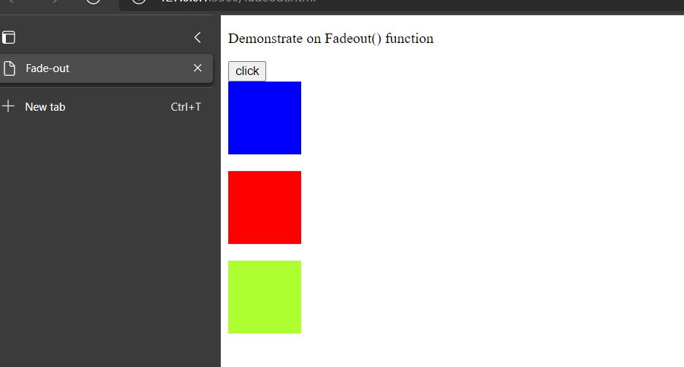

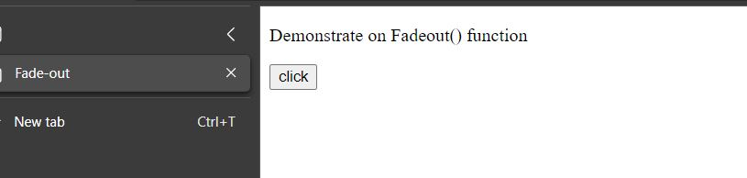

1. **fadeToggle():**

**<!DOCTYPE html>**

**<html>**

**<head>**

**<script src="https://code.jquery.com/jquery-3.6.0.js">**

**</script>**

**<script>**

**$(document).ready(function()**

**{**

**$("button").click(function()**

**{**

**$("#div1").fadeToggle();**

**$("#div2").fadeToggle("fast");**

**$("#div3").fadeToggle(4000);**

**}**

**);**

**}**

**);**

**</script>**

**</head>**

**<body>**

**<h3 align="Practical of fadtoggle"></h3>**

**<button>Click</button>**

**<div id="div1" style="background-color: blueviolet; width: 50px; height: 50px;"></div><br/>**

**<div id="div2" style="background-color: royalblue; width: 50px; height: 50px;"></div><br/>**

**<div id="div3" style="background-color: red; width: 50px; height: 50px;"></div><br/>**

**</body>**

**</html>**

* **the Motive of this practical is that, you can Hide and show the boxes by clicking on click button . this will happen because of fadeToggle() Method.**
* **OUTPUT :**

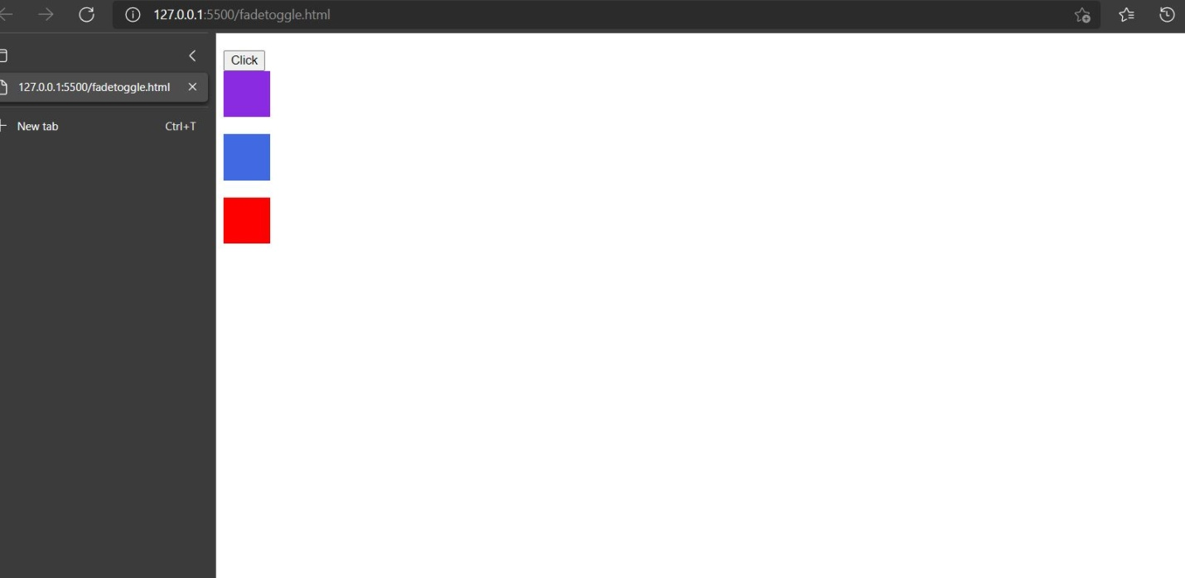

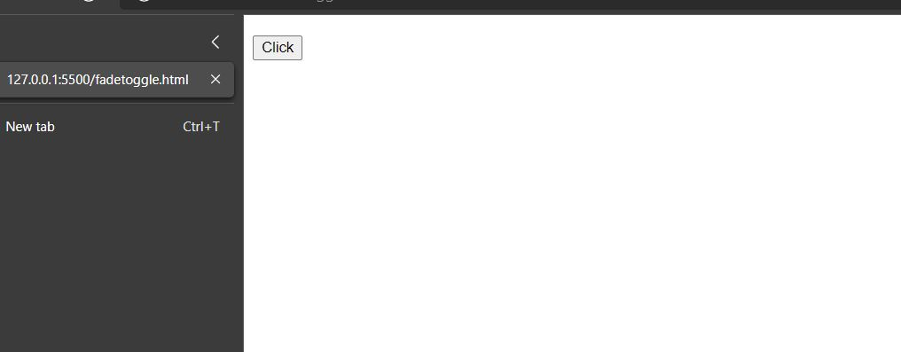

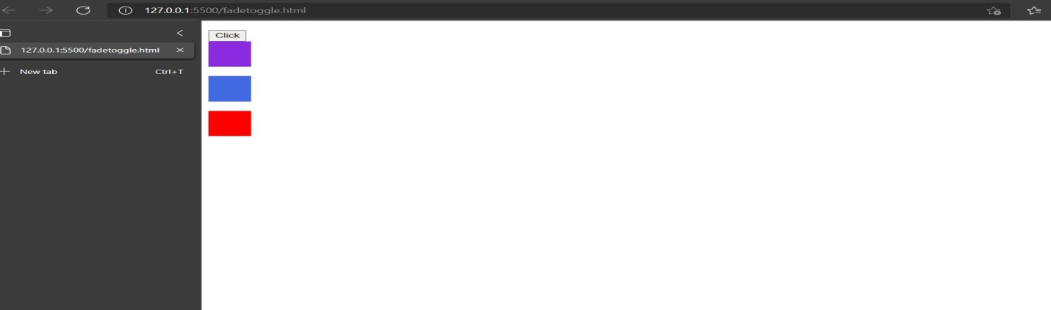

1. **fadeTO():**

**<!DOCTYPE html>**

**<html>**

**<head>**

**<script src="https://code.jquery.com/jquery-3.6.0.js">**

**</script>**

**<script>**

**$(document).ready(function()**

**{**

**$("button").click(function()**

**{**

**$("#div1").fadeTo("slow",0.1);**

**$("#div2").fadeTo(1000,0.5);**

**$("#div3").fadeTo(2000,0.4);**

**}**

**);**

**}**

**);**

**</script>**

**</head>**

**<body>**

**<h3 align="Practical of fadto"></h3>**

**<button>Click</button>**

**<div id="div1" style="background-color: blueviolet; width: 50px; height: 50px;"></div><br/>**

**<div id="div2" style="background-color: royalblue; width: 50px; height: 50px;"></div><br/>**

**<div id="div3" style="background-color: red; width: 50px; height: 50px;"></div><br/>**

**</body>**

**</html>**

* **fadeTo() method animates the opacity of the matched elements. It is similar to the . fadeIn() method but that method unhides the element and always fades to 100% opacity. Durations are given in milliseconds; higher values indicate slower animations, not faster ones. The output will be displayed as below.**

**OUTPUT :**

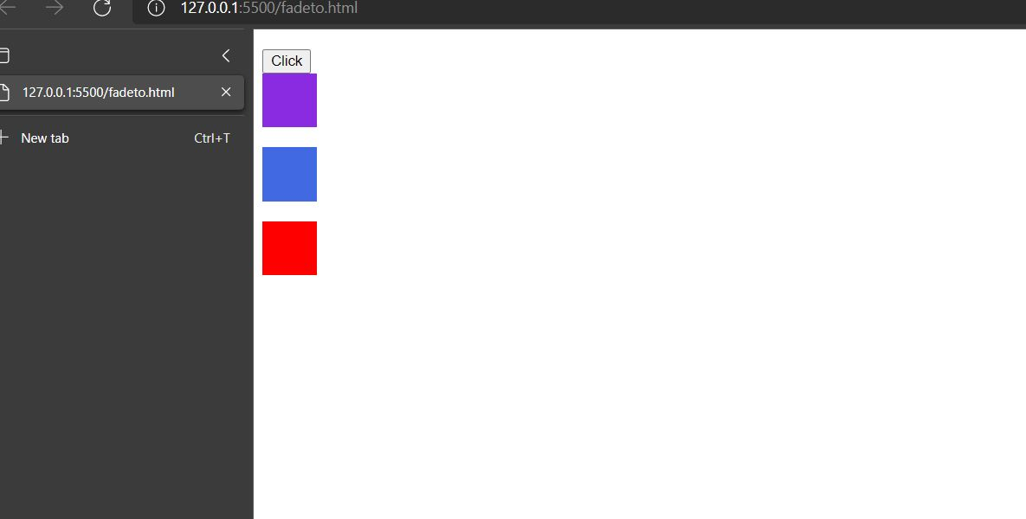

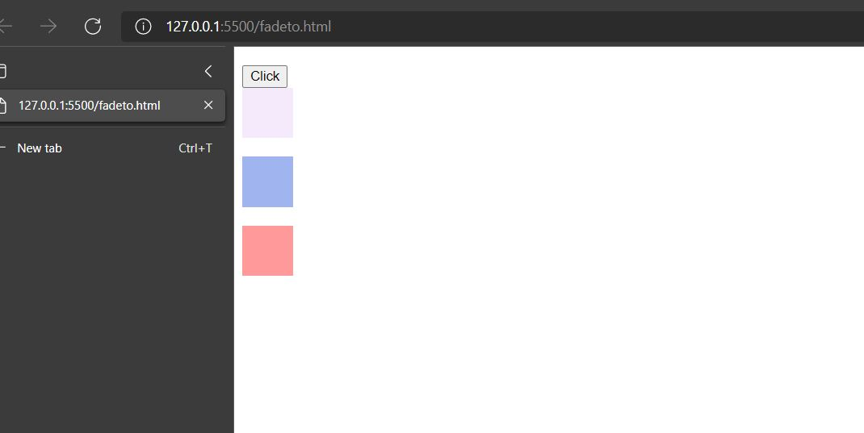

**Slide() Methods:**

1. **slideUp() :**

**<html>**

**<head>**

**<script src="https://code.jquery.com/jquery-3.6.0.js">**

**</script>**

**<script>**

**$(document).ready(function()**

**{**

**$("#line").click(function()**

**{**

**$("#panel").slideUp("fast");**

**}**

**);**

**}**

**);**

**</script>**

**<style>**

**#panel,#line{**

**padding: 5px;**

**text-align: center;**

**font-family: cursive;**

**background-color: blueviolet;**

**border:solid 3px black;**

**}**

**#panel{**

**padding: 50px;**

**}**

**</style>**

**</head>**

**<body>**

**<div id="line">slideup by clicking</div>**

**<div id="panel">ARPAN BHOI</div>**

**</body>**

**</html>**

* **The slideUp() is an inbuilt method in jQuery which is used to hide the selected elements. Syntax: $(selector). slideUp(speed); Parameter: It accepts an optional parameter “speed” which specifies the speed of the duration of the effect.**
* **As you can see there is One Panel like “Arpan Bhoi”. By clicking Slideup button ,the panel will be going up endside.**

**OUTPUT : FIG 1**

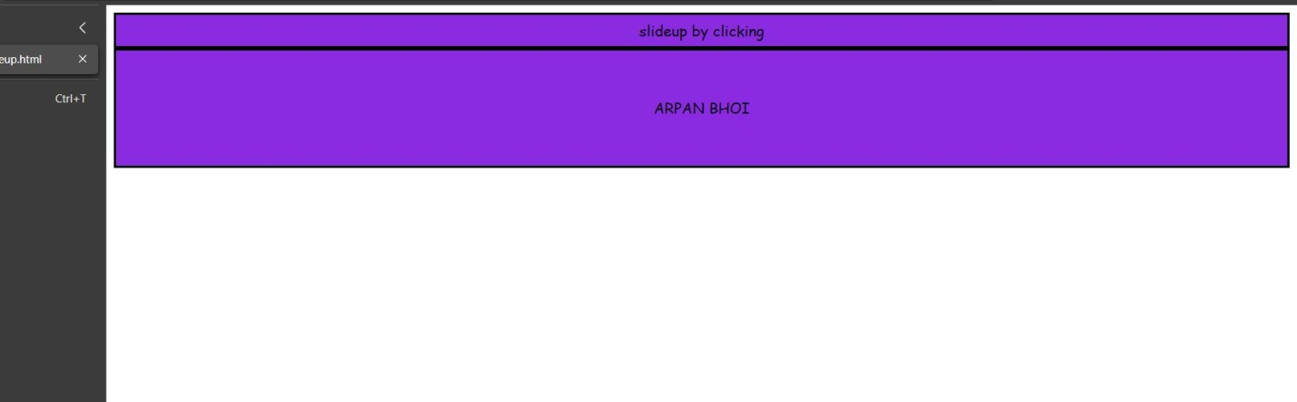

**FIG 2**

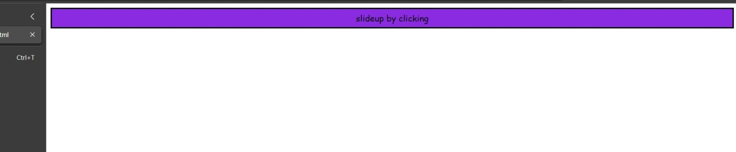

1. **slideDown():**

**<html>**

**<head>**

**<script src="https://code.jquery.com/jquery-3.6.0.js">**

**</script>**

**<script>**

**$(document).ready(function()**

**{**

**$("#line").click(function()**

**{**

**$("#panel").slideDown("fast");**

**}**

**); });**

**</script>**

**<style>**

**#panel,#line{**

**padding: 5px;**

**text-align: center;**

**font-family: cursive;**

**background-color: blueviolet;**

**border:solid 3px orange;**

**}**

**#panel{**

**padding: 50px;**

**display: none;**

**}**

**</style>**

**</head>**

**<body>**

**<div id="line">slideDown by clicking</div>**

**<div id="panel">ARPAN BHOI</div>**

**</body>**

**</html>**

* **it’s the reverse case of slideup method. After clicking on slidedown button, the panel will be going down.**
* **You should use slidedown() method in your practical. This is the only difference between slideup() and slidedown() method.**
* **In slidedown() method, you can add effect like “Fast” ,”slow” . as you can see in line number 13.**

**OUTPUT : FIG1**

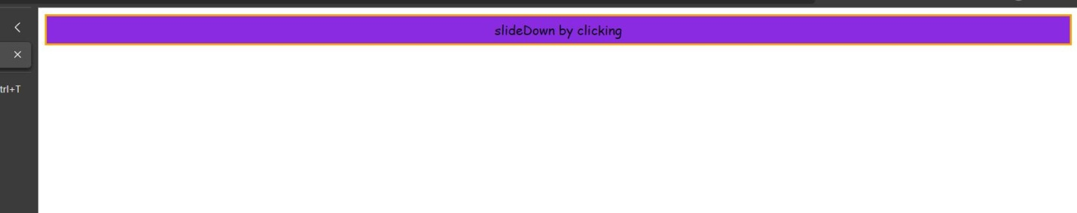

**FIG 2**

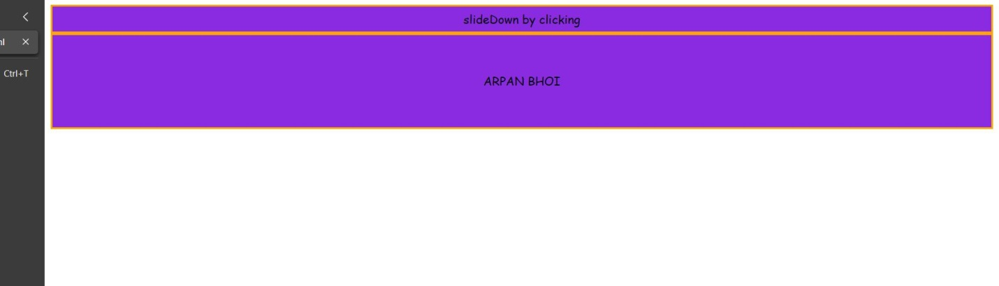

1. **slideToggle():**

**<html>**

**<head>**

**<script src="https://code.jquery.com/jquery-3.6.0.js">**

**</script>**

**<script>**

**$(document).ready(function()**

**{**

**$("#line").click(function()**

**{**

**$("#panel").slideToggle("fast");**

**}**

**); });**

**</script>**

**<style>**

**#panel,#line{**

**padding: 5px;**

**text-align: center;**

**font-family: cursive;**

**background-color: darkgoldenrod;**

**border:solid 1px blue;**

**}**

**#panel{**

**padding: 50px;**

**display: none;**

**}**

**</style>**

**</head>**

**<body>**

**<b> <div id="line">slidetoggle by clicking</div>**

**<div id="panel">ARPAN BHOI</div></b>**

**</body>**

**</html>**

* **slideToggle() method is the Combination Of Slidedown() and slideup() method. It means by clicking one button you can do slideup and slidedown the panel.**

**OUTPUT :**

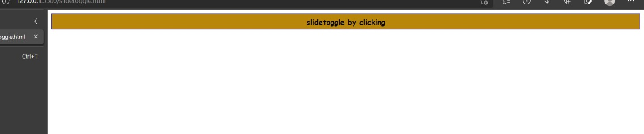

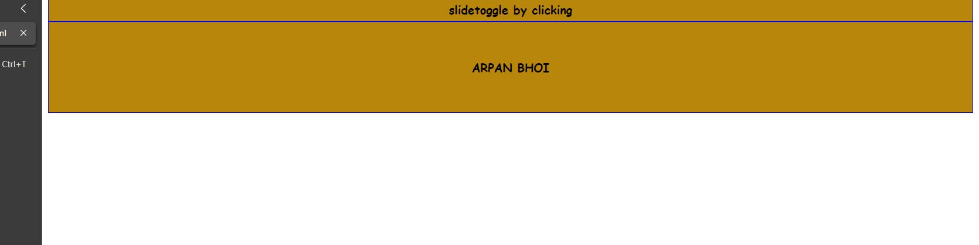

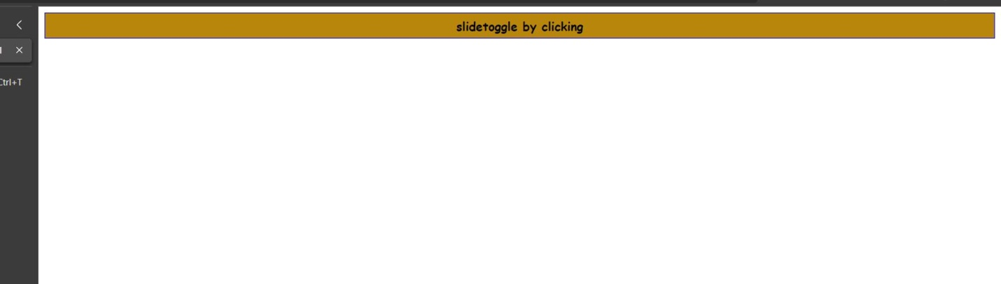

* **Element-Selector :**

**<!DOCTYPE html>**

**<html>**

**<head>**

**<title>Document</title>**

**<script src="https://code.jquery.com/jquery-3.6.0.js"></script>**

**<script>**

**$(document).ready(function()**

**{**

**$("button").click(**

**function()**

**{**

**$("p").hide();**

**}**

**);**

**}**

**);**

**</script>**

**</head>**

**<body bgcolor="Purple">**

**<label>This is a practical of jquery</label>**

**<p>This will bo going to hide ...do you have any query!!!!!!!</p>**

**<button>Click on me please!!!!!!</button>**

**</body>**

**</html>**

* **As we know that the selection can be the basic HTML elements such as <p>,<div>,<h1>,<form> etc**
* **In the above practical , the button element selector the action is click. This action invokes the <p> element and the action associated with this element is hide.**

**OUTPUT :**

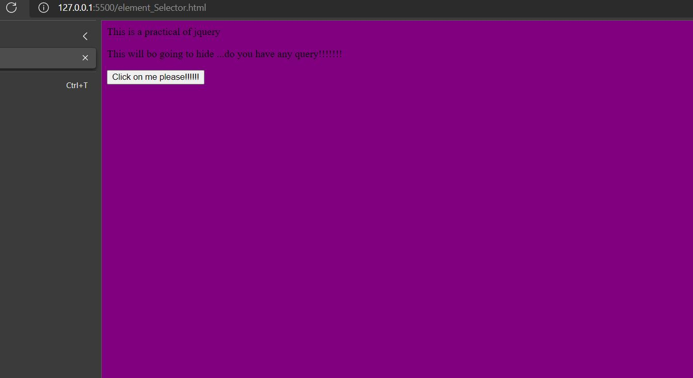

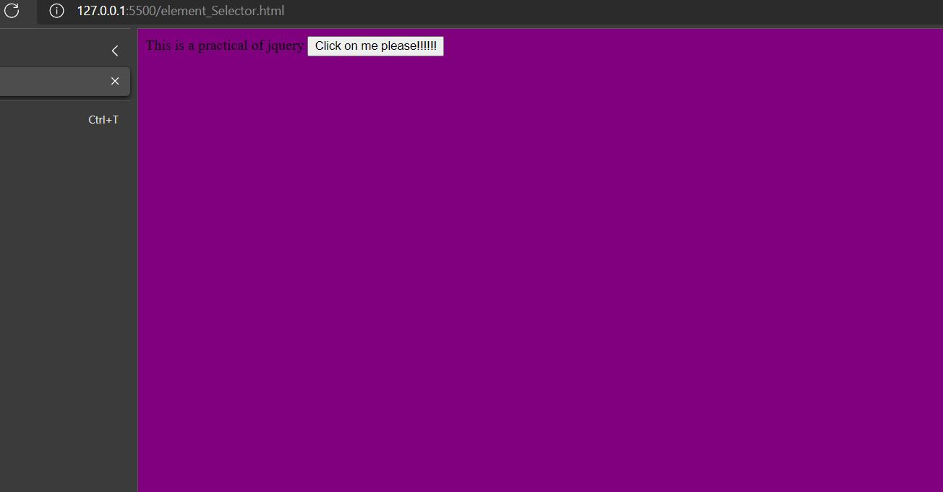

* **Href –selector :**

**<!DOCTYPE html>**

**<html>**

**<head>**

**<title>href selector :</title>**

**<script src="https://code.jquery.com/jquery-3.6.0.js">**

**</script>**

**<script>**

**$(document).ready(function()**

**{**

**$("#btn1").click(function()**

**{**

**$("[href]").hide();**

**}**

**);**

**$("#btn2").click(function()**

**{**

**$("[href]").show();**

**}**

**);**

**}**

**);**

**</script>**

**</head>**

**<body>**

**<center><h1 align="center" tect>Href selector : </h1>**

**<a href="https://www.djmit.ac.in"><abbr title="Dr.Jivraj Mehta Institute of Technology">DJMIT</abbr> <abbr title="College">CLG</abbr></a><br/><br/>**

**<button type="button" id="btn1">Hide</button>**

**<button type="button" id="btn2">Show</button>**

**</center>**

**</body>**

**</html>**

* **The href element is used along with the anchor tag in order to introduce hyperlink in the web document. We can navigator to the desired web page using such hyperlinks.**
* **As you can see in above program , I have used djmit clg web site link. In the main method I have applied two methods such as HIDE() & SHOW(). With the help of these two methods, I can hide and show hyperlinks.**
* **Now , you can see the below output.**

**OUTPUT :**

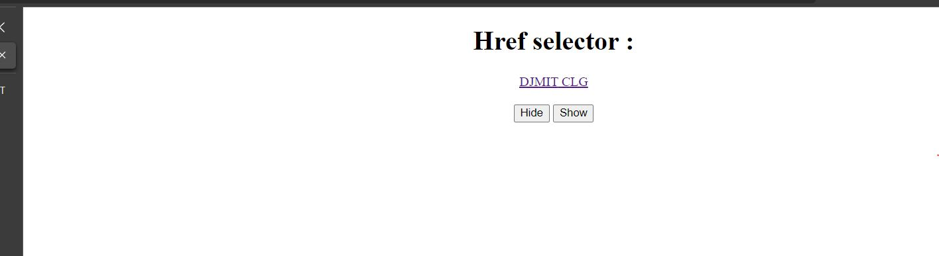

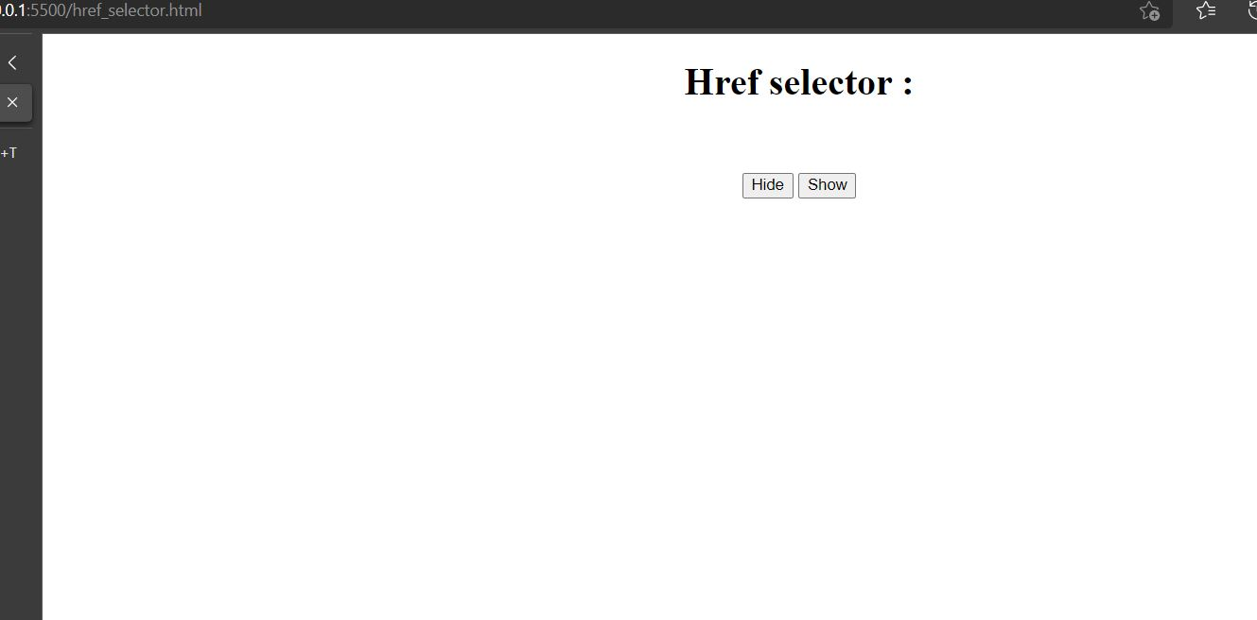

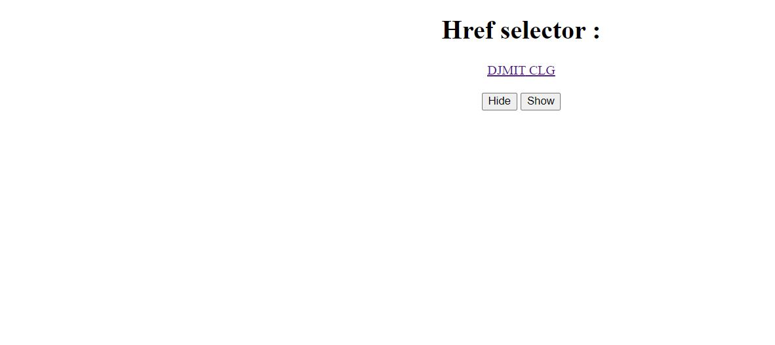

* **Id-Selector :**

**<!DOCTYPE html>**

**<html>**

**<head>**

**<title>Image load practical :</title>**

**<script src = "https://code.jquery.com/jquery-3.6.0.js">**

**</script>**

**<script>**

**$(document).ready(function()**

**{**

**$("#btn1").click(**

**function()**

**{**

**$("#imgDiv").show();**

**}**

**);**

**$("#btn2").click(**

**function()**

**{**

**$("#imgDiv").hide();**

**}**

**)} );**

**</script>**

**</head>**

**<body>**

**<h1 align="center">Image is Loading.....</h1>**

**<div id="imgDiv">**

**<center> <img src="E:\Web Programming\Jquery\th.jpg"></center></div>**

**<center> <button type="button" id="btn1">Show</button>**

**<button type="button" id="btn2">Hide</button>**

**</center></body></html>**

* **The id can be associated with the html elements. In this example we have used <div>(line number :30) element to which the id named “#imgDiv” is associated. On button click event the function is invoked to hide the Sentences written using the <div id=”imgDiv”>.**
* **To find the element with particular id write # and then name of the id.**

**OUTPUT :**

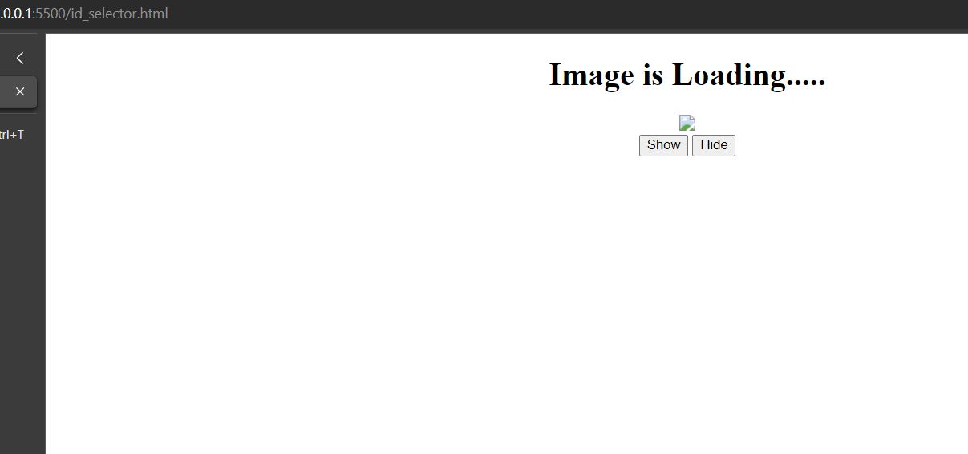

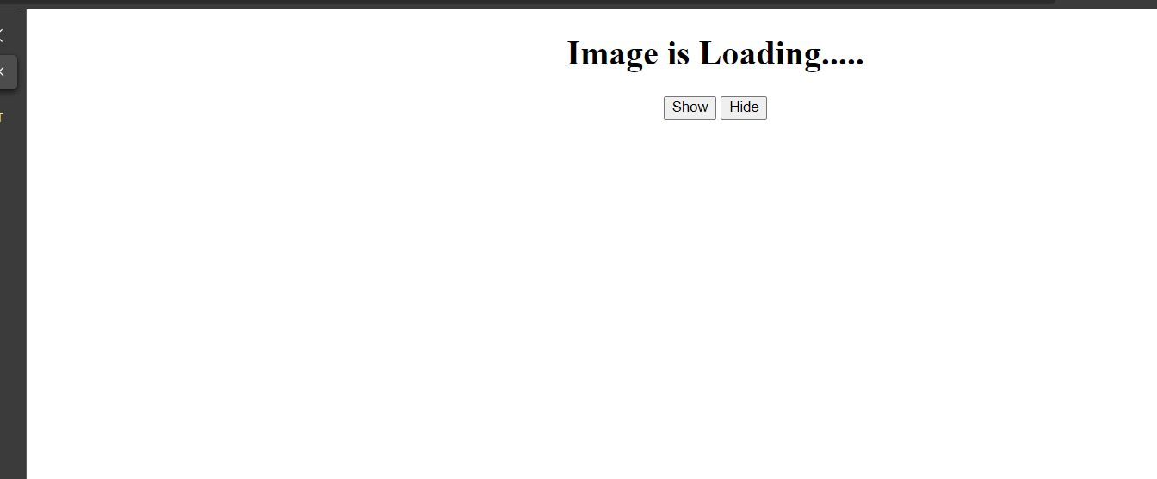



* **\* selector :**

**<!DOCTYPE html>**

**<html>**

**<head>**

**<title>Use * as a selector ::</title>**

**<script src="https://code.jquery.com/jquery-3.6.0.js">**

**</script>**

**<script>**

**$(document).ready(function()**

**{**

**$("button").click(**

**function()**

**{**

**$("*").hide(); <!------ * is used as selector,,after clicking ,all the contents are removed.----->**

**}**

**);**

**}**

**);**

**</script>**

**</head>**

**<body>**

**<h1 align="Center"> * Selector :</h1>**

**<p align="Center">This is one paragraph</p>**

**<center><button>Click</button></center>**

**</body>**

**</html>**

* **The * means all. If we include selector as * then the corresponding action will be associated with all the html element. the sample code for demonstrating this action is as above.**

**OUTPUT :**

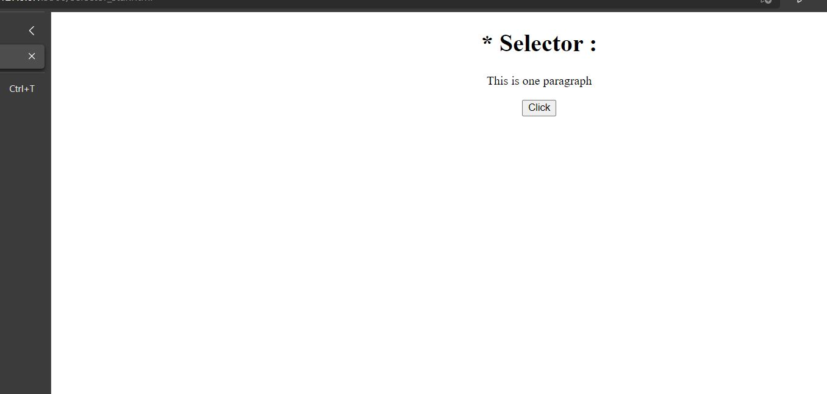



* **Tr-Selector:**

**<!DOCTYPE html>**

**<html>**

**<head>**

**<title>TR_Selector : </title>**

**<script src="https://code.jquery.com/jquery-3.6.0.js">**

**</script>**

**<script>**

**$(document).ready(function()**

**{**

**$("tr:odd").css("background-color","orange");**

**} );**

**</script></head> <body> <table border="2">**

**<tr>**

**<th>Name :</th>**

**<th>Department :</th>**

**<th>Address : </th>**

**</tr><tr>**

**<td>Arpan</td>**

**<td>CSE</td>**

**<td>Anand</td></tr>**

**<tr>**

**<td>Mihir</td>**

**<td>Homeopath</td>**

**<td>Thermal</td>**

**</tr><tr>**

**<td>Harsh</td>**

**<td>CSE</td>**

**<td>Baroda</td>**

**</tr><tr>**

**<td>Vikas</td>**

**<td>CSE</td>**

**<td>Rajasthan</td>**

**</tr></table></body> </html>**

* **The element is used to define the rows of the table. We can denote this selector along with the css style. It is demonstrated by Above Coding.**

**OUTPUT :**

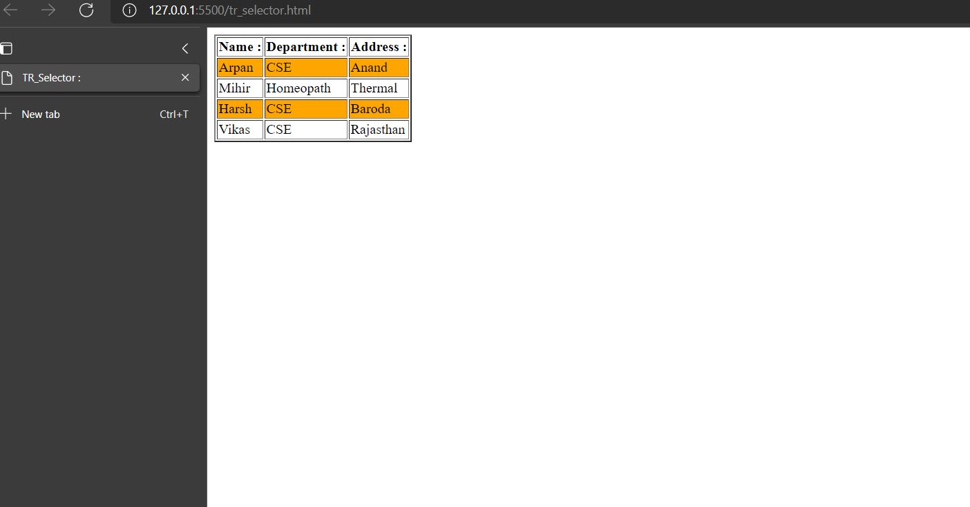

* **remove() Method :**

**<html>**

**<head>**

**<script src="https://code.jquery.com/jquery-3.6.0.js">**

**</script>**

**<script>**

**$(document).ready(function()**

**{**

**$("button").click(function()**

**{**

**$("#tb").remove();**

**} ); });**

**</script>**

**</head>**

**<body>**

**<center> <table id="tb" border="2">**

**<tr>**

**<td>1</td>**

**<td>2</td>**

**<td>3</td>**

**</tr>**

**<tr>**

**<td>4</td>**

**<td>5</td>**

**<td>6</td>**

**</tr></table><br/>**

**<button id="button">Remove</button>**

**</center>**

**</body>**

**</html>**

* **to remove elements from the dom there are two commonly used methods- remove and empty Jquery .empty() method removes all the child element of the matched element where remove() method removes set of matched elements from dom.**

**OUTPUT :**

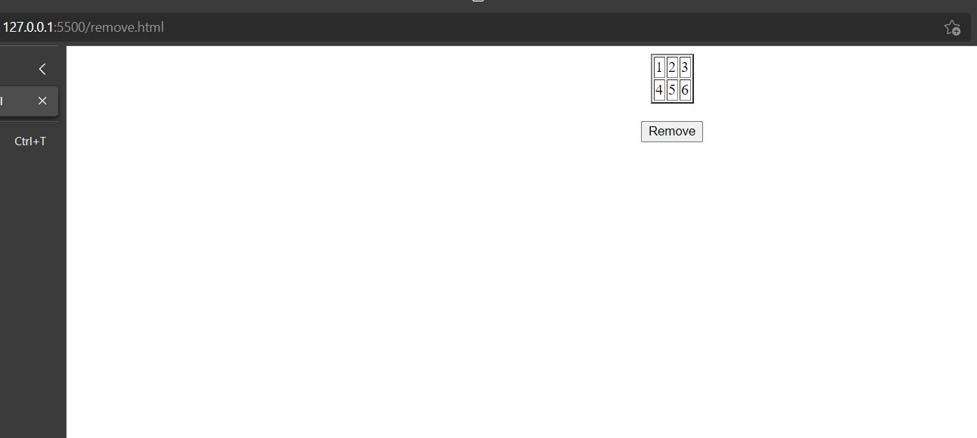

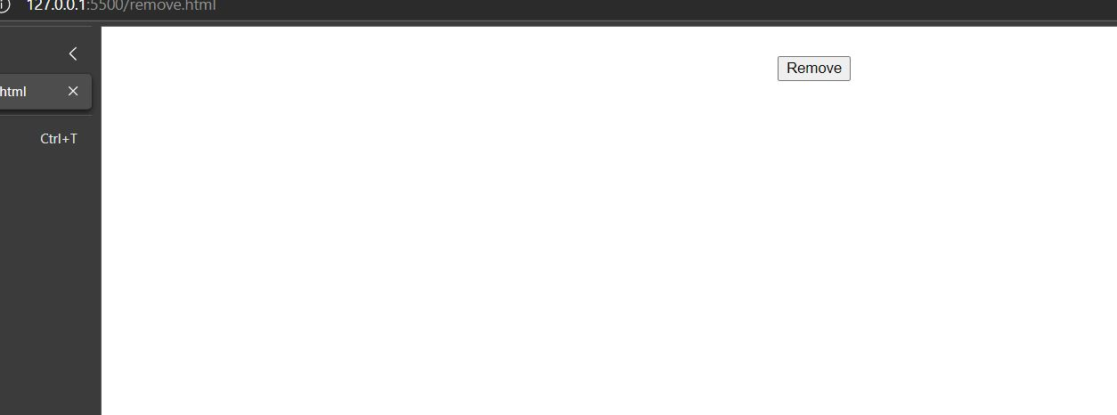

* **empty() Method :**

**<html>**

**<head>**

**<script src="https://code.jquery.com/jquery-3.6.0.js">**

**</script>**

**<script>**

**$(document).ready(function()**

**{**

**$("button").click(function()**

**{**

**$("#tb tr td").empty(); // #tb tr td,this is as a sysntax of empty method.**

**}); }**

**);**

**</script>**

**</head>**

**<body>**

**<center> <table id="tb" border="2">**

**<tr>**

**<td>1</td>**

**<td>2</td>**

**<td>3</td>**

**</tr>**

**<tr>**

**<td>4</td>**

**<td>5</td>**

**<td>6</td>**

**</tr></table><br/>**

**<button id="button">Do Empty</button>**

**</center>**

**</body>**

**</html>**

* **I have Already given the explanation of this method in remove() method.**

**OUTPUT :**

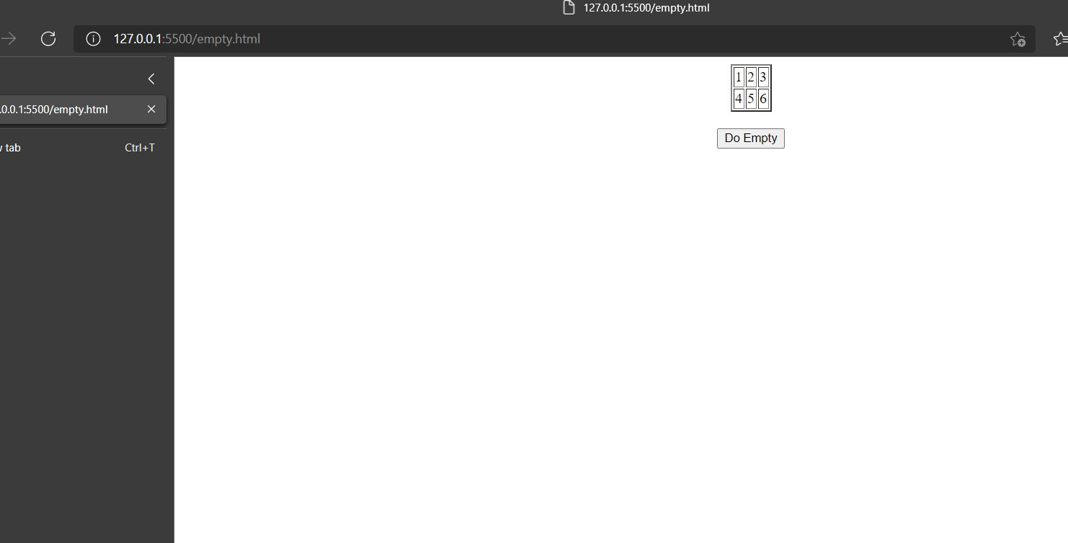

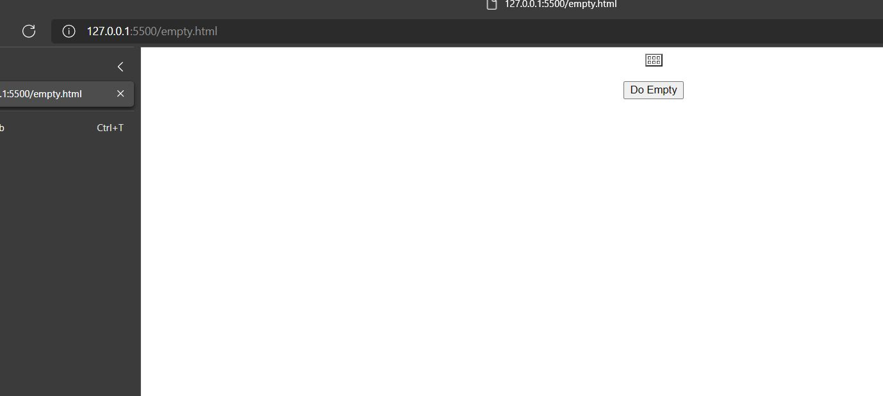

* **.css Method :**

**<!DOCTYPE html>**

**<html>**

**<head>**

**<title></title>**

**<script src="https://code.jquery.com/jquery-3.6.0.js">**

**</script>**

**<script>**

**$(document).ready(function()**

**{**

**$("button").click(function()**

**{**

**$("div").css("background-color","lightblue");**

**}**

**);**

**}**

**);**

**</script>**

**</head>**

**<body>**

**<h1 align="center">Changing style :</h1>**

**<div style="background-color: blue">This line has blue color</div>**

**<div style="background-color: yellow">This line has yellow color</div>**

**<button>Click to change : </button>**

**</body>**

**</html>**

* **To change the style the .css() function is used. And the syntax is**

**$(selector).css({“css property name”:”css property value”});**

**OUTPUT :**

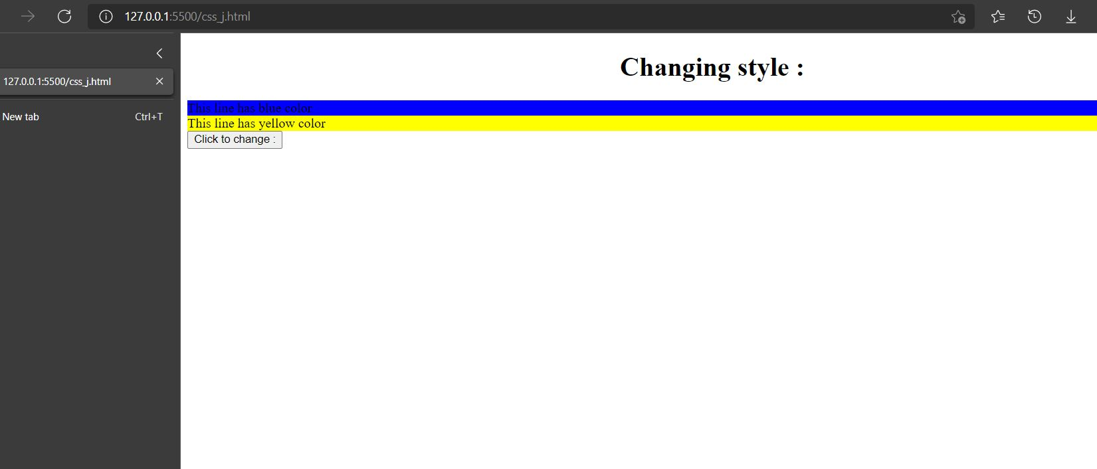

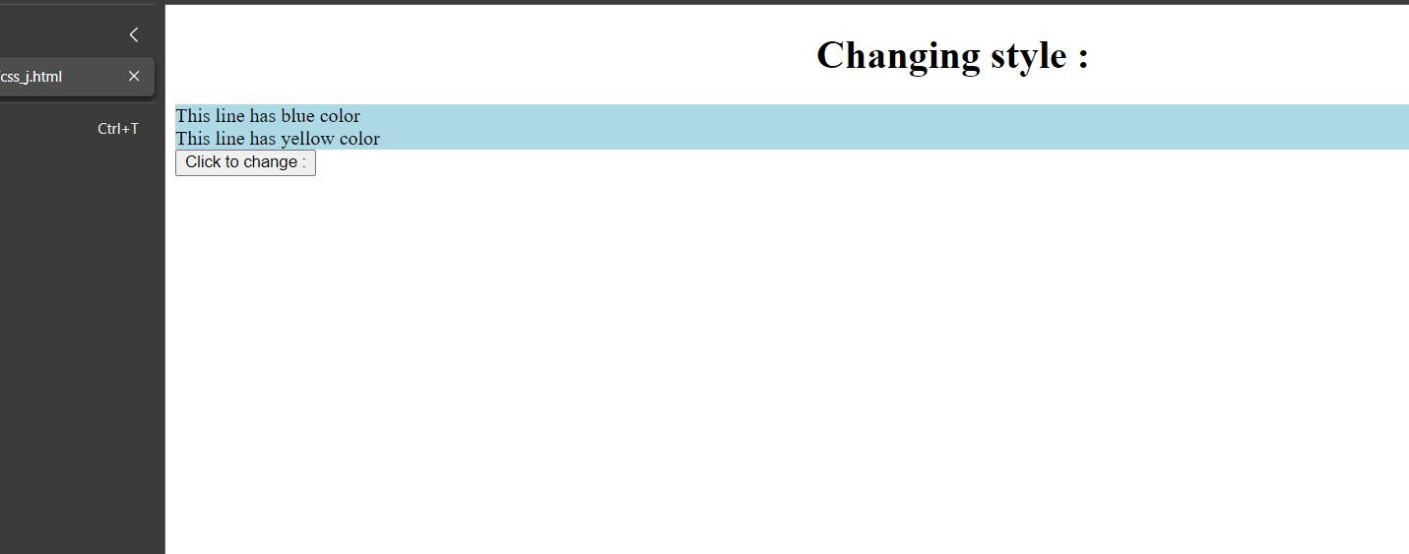

* **Append() method :**

**<html>**

**<head>**

**<script src="https://code.jquery.com/jquery-3.6.0.js">**

**</script>**

**<script>**

**$(document).ready(function()**

**{**

**$("button").click(function()**

**{**

**$("ol").append("<li>Majama!!</li>");**

**}**

**);**

**}**

**);**

**</script>**

**</head>**

**<body>**

**<ol type="1">**

**<li>Kese ho!!</li>**

**<li>Hello</li>**

**<li>Hi</li>**

**<li>GOOD</li>**

**</ol></br>**

**<button id="button">Append Element</button>**

**</body>**

**</html>**

* **We can add new element at the end of existing elements using the append function. The appending of elements can be well understood by following above example.**

**OUTPUT :**

